February 27

This condo is a hive — dozens of little cells glued together. This whole neighborhood is just more hives stacked side by side. And we? We’re thousands of bees that don’t work together, don’t know each other, don’t even bother to say hello when we cross paths.

This morning, I wanted to take Emy to the place where I used to play as a kid. But while I was growing up, the town was growing old. Maybe the trees were already old too, because now they’re gone — dead or uprooted. Where the fields used to be, there's just a stretch of concrete, two crooked playground rides, and people with empty stares, more lost than ever.

Morning. Another fight with my father. He didn’t sugarcoat it: I had to get a job and take care of myself. My family couldn’t carry me anymore.

Afternoon. Three shirts, two tracksuits, underwear, and a duffel bag on the bed. No speeches, no drama. Just a message to Francesco: “I’ve got a contact in Ischia, we’re leaving tonight.”

February 27, but it could have been January, December, whenever — in this city the air’s never been breathable. And home? Don’t get me started. When my dad’s around, it’s just yelling. My girl’s ready to leave me. And here at home, it’s obvious: I’m the extra one.

February 27, night.
Fratta station. The tracks blur behind the pouring rain, but our train’s there. By dawn, we’re in Naples. Corso Umberto, drenched. Then Molo Beverello. That’s where the boats to the islands leave from. We book tickets from our phones, and by 3 p.m., we’ve got an island under our feet.

February 29.
The island was a beginning. I started working right away — restaurant gig with a dozen locations. One night they’d give me cash and a ticket for the next day: “Go cover a shift over there.” Sometimes still on the island, sometimes on the mainland. Rome, mostly. First once, then again. Then they told us to stay.

March 16.
Now we’re based in Rome. The city’s huge — to us, it feels like Vegas, but with more Chinese shops. And hey, every now and then, you even spot a tree.

The restaurant gave us housing too — me, Francesco, and eleven other waiters and dishwashers. Socks, sweat, and a mess of languages. At night, we were so dead tired that the only thing we shared were cigarettes — stolen, begged, passed around like gold. But man, the atmosphere.

That time taught me a lot. I had to do everything on my own. The apartment was crap, pay came only at the end of the month, and in the mornings Francesco and I would count our coins — never enough, not even for one.

I’m not ashamed to say it: one night, we were flat broke. A guy I served pizza to came up and asked if I had anything to spice up his night.

I didn’t. But I’d seen those little bags left on the tables. I ran upstairs, grabbed a half-empty one, crushed up two painkillers, filled it. With the cash, we ate. Maybe I lost a bit at the slots, too. But the guy came back the next day. And the one after. Always asking for me.

Truth? I was in deep. But I got out.

I don’t regret it. We were broke. We needed to eat. We’d been wearing the same tracksuits for days...

That low point taught me something: I could do anything. Thought, action. Thought, action. That’s when Francesco and I headed to Treviso — chasing two girls we’d met on Insta. Haircuts, train tickets, even flowers. Two hundred and fifty euros.

They never showed.

We were pissed. Crushed. But every time we talk about it now, we laugh — thinking of that Padova–Conegliano train, us dodging the conductor without tickets, flowers still in hand two days later, trailing petals down the aisle like idiots in a movie.

Everything that happened there — and everything that happened before — those are the words I write into my verses now.

It was a wild, brutal phase. Quick, and unforgiving. But it changed how I live, how I see the world, how I spend and how I earn. It gave me real friendships that still hold today. And it taught me the only way to grow is to leave your hive, go looking for others, look people in the eye, and say good morning.

Me and Francesco came out better for it.

I think it all happened because Frattamaggiore — with its thousands of people — always felt too small for me. And maybe that’s why I write. To escape. And maybe, just maybe, it’ll be my ticket to leave this place for good.

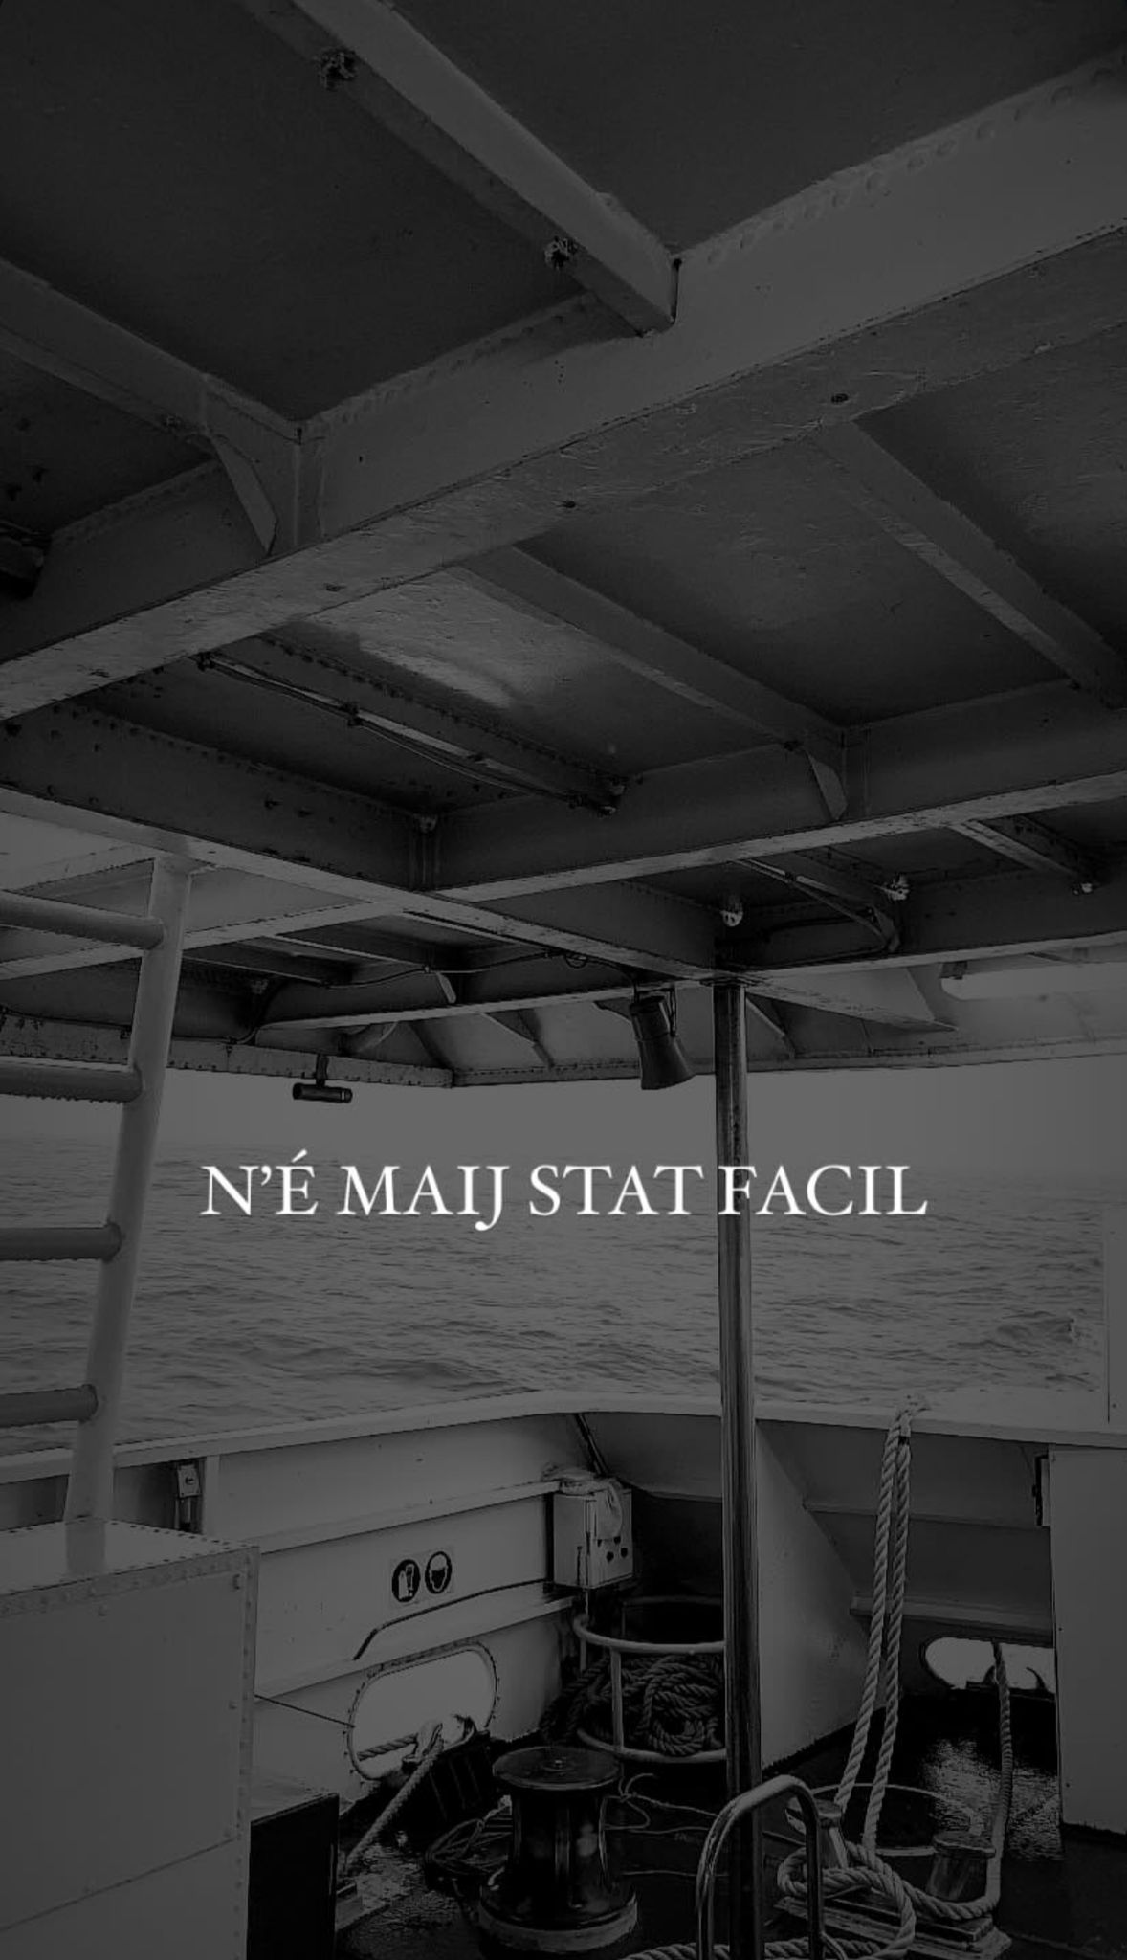

Gaetano Instagram Story the day he feft

STORY REPORT FORM
This form should accompany the stories of challenge / change that you collected from your partners, stakeholders, staff, community members and volunteers (one form for each story). The stories themselves can be written up or take the form of photos, short videos, drawings, poetry, etc.
Name of the organisation and person collecting the story:

The story was collected for Cantiere Giovani by Sirio and Luca.
Sirio works as head of International dept anche Luca is a youthworker. They arranged three meeting with young people hanging out at IL Canteere, the youthcenter run by the organization, and came up with this story.
The youth center is in Frattamaggiore, a village in the northern periphery of Naples.

Who provided the story and in which form:

The story was provided by Gaetano, 20 yo, who hang out at the youthcenter every now and then. His best friend Francesco (19yo) would throw a comment form time to time since he was present when it all happened.
The second time we met they came with some words written as rap “bars” in 4/4. We tried to dig deeper in the events (looking for a story, not just the feeling it brought with) and recorded a conversation of almost 1 hour.

When and where did the challenges/changes illustrated in the story take place:

This is a personal story — or rather, a sequence of events unfolding almost as a stream of consciousness — that emerged from the protagonists’ difficult relationship with their urban environment: a hyper-cementified, unsustainable landscape from an environmental standpoint.

As the story progressed, deeper layers came to light — social distress, the weight of youth unemployment — but we chose not to interrupt the flow of narration, as the storyteller was deeply immersed and emotionally involved in the recounting.

These are, nonetheless, events that brought about a significant transformation in the lives of the protagonists, all taking place between the months of February, March, and April 2024.
What kind of projects were implemented by your organisation in the place the story refers to :

Cantiere Giovani carries out several projects aimed at promoting well-being and encouraging youth empowerment and youth protagonism, both at the Il Cantiere youth center and in the city’s more socio-economically challenged neighborhoods.
Through the project “Si Può Fare” (“you can do it”), it supports informal groups of young people who want to take action in their communities through urban regeneration initiatives, even if they choose not to go through traditional forms of formal associations
What does the storyteller believe is the significance of the events described in the story?

Gaetano, and to some extent Francesco, have expressed how living in an overbuilt urban environment that’s not designed with people in mind makes them feel isolated, anxious, and inadequate. This only amplifies the struggles and tensions they face in their family and community context in general, partly due to their age and partly due to external socio-economic factors

They believe that escaping at night, and wandering without a long-term plan but simply following the events as they unfolded, was the only way to break free from the reality that made them feel trapped. At the same time, it changed their approach to life, transforming it from something inevitable to something they could write with their own hands, trying to shape the events of their lives.

